**<Predicting Anxiety Disorder through Sociodemographic Factors Across the U.S>**

**<Mohammad Mousavi, mmousavi2, mmousavi@udel.edu, data curator>**

**<John Uponi, John-Uponi, jiuponi@udel.edu, data analysis>**

***Abstract***

Anxiety disorders are a common mental health condition in the U.S affecting millions of adults and children. This project examines the factors that contribute to anxiety disorder across the U.S in the year 2022, this is significant because it would enable us to determine the major contributors to anxiety disorders and areas the government can intervene to reduce the widespread occurrence a brief statement about the project scope, significance, and relevance to machine learning urban science topics.

***Introduction***:

Anxiety disorders are among the most prevalent mental health issues affecting individuals. The World Health Organization (WHO) reports that 13% of people worldwide suffer from mental illnesses that often go undiagnosed or untreated (World Health Organization, 2022). Untreated anxiety disorders can lead to significant mental and physical health challenges that persist throughout a person’s life (Gale et al., 2014). In the United States, approximately 30% of the population is diagnosed with anxiety disorders, emphasizing the critical need for intervention (Newman et al., 1996). Previous studies have shown that employment status can significantly affect the rates of reporting anxiety disorders, suggesting that individuals who are unemployed or underemployed may experience higher levels of anxiety compared to those in stable employment (Hiswåls et al., 2017).

This research project aims to identify who is at greater risk of experiencing anxiety disorders, with a particular emphasis on the impact of sociodemographic variables. By understanding effective sociodemographic factors in anxiety disorder prevalence across the U.S., we can better tailor interventions to promote mental health, safety, and well-being. Additionally, these findings can inform strategies to decrease health disparities and as an important movement for policymakers to directly enhance mental health outcomes.

***Questions and Hypothesis***

Question 1:

Can anxiety disorder be predicted through sociodemographic factors?

Null Hypothesis 1 (H0)

H0: Sociodemographic factors cannot predict anxiety disorder.

Alternative Hypothesis 1 (H1)

H1: Sociodemographic factors can predict anxiety disorder.

Question 2:

Is there a difference in the prevalence of anxiety disorders between males and females across the U.S.?

Null Hypothesis 2 (H0)

H0: There is no significant difference in the prevalence of anxiety disorders between males and females across the U.S. population.

Alternative Hypothesis 2 (H1)

H1: There is a significant difference in the prevalence of anxiety disorders between males and females across the U.S. population.

***Data***

We use mental health client level data (MH-CLD) 2022, using only columns relevant for this study which includes: Gender, Race, Ethnicity,Education,Age, Employment status, Residential Status, Marital status, Reporting state code. Target: Anxiety disorder

We cleaned the dataset by removing any individuals containing missing values in any of these columns. Moreover, we excluded participants from Puerto Rico (72) and other jurisdictions (99), retaining data only from the 50 states (637,255 clients).

Figure 1: Data of people with reported Disorder

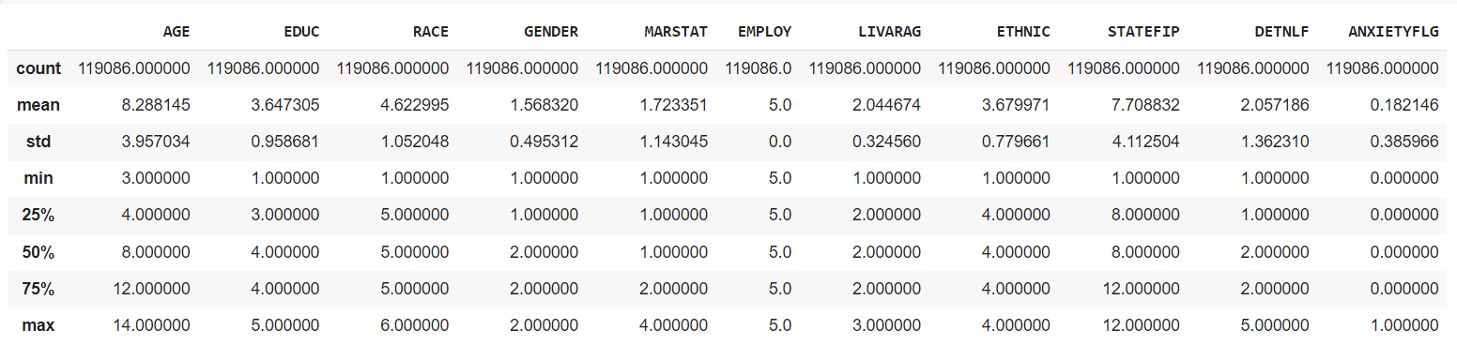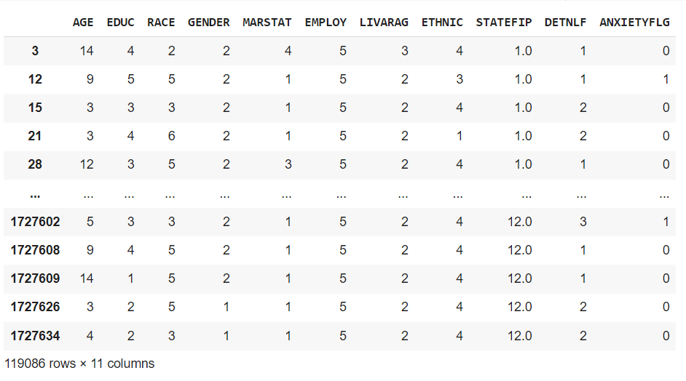

We went further to plot the prevalence of anxiety disorder amongst genders and different employment status. We also assessed the prevalence of anxiety disorder by gender and employment status by states.

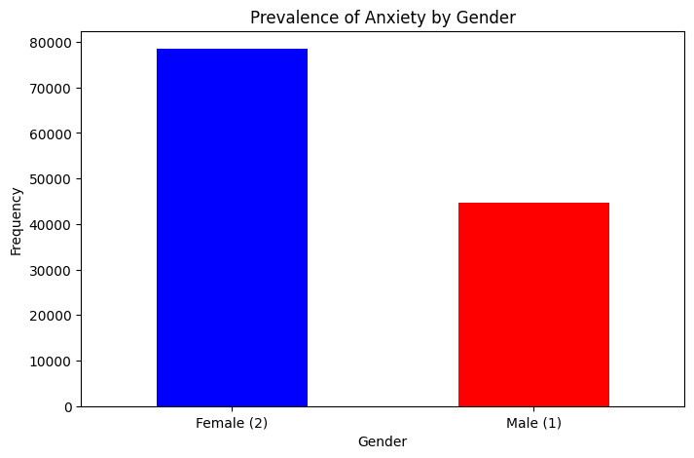

Figure 2: Prevalence of anxiety by gender

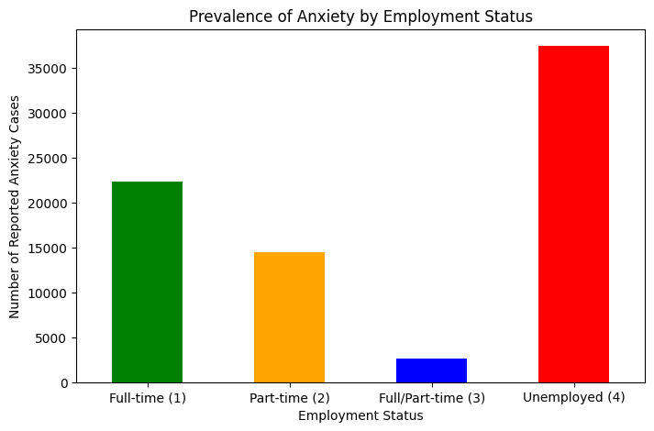

Figure 3: Prevalence of Anxiety by employment status

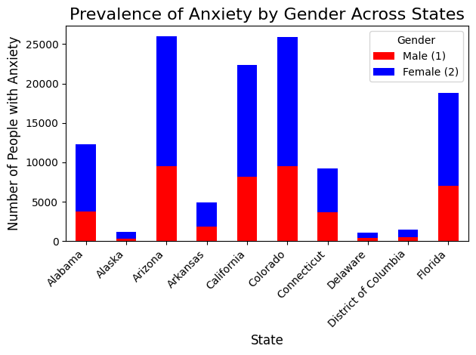

Figure 4:Prevalence of anxiety by gender across states

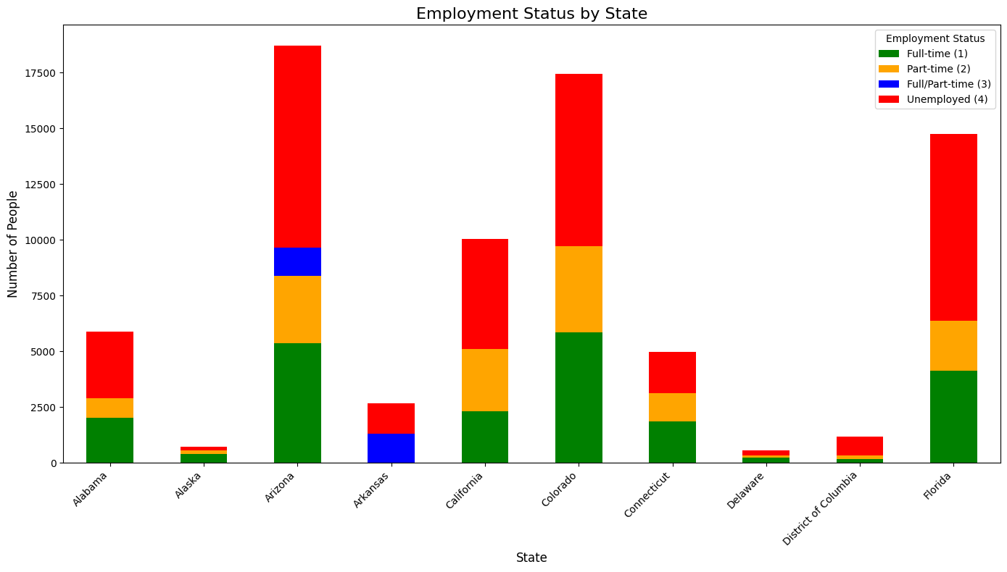

Figure 5: Prevalence of anxiety by employment status across states.

| **Dataset name** | **URL** | **Number of rows** | **Number of columns** | **Number of relevant columns** | **Number of valid rows (not NaN on relevant columns)** | **Data type for each relevant column** |
| --- | --- | --- | --- | --- | --- | --- |
| **Mental Health client-level data** | **https://www.datafiles.samhsa.gov/dataset/mental-health-client-level-data-2022-mh-cld-2022-ds0001** | **1727637** | **40** | **11** | **119086** |  |
| **Geospatial data** | [**https://www.census.gov/data.html**](https://www.census.gov/data.html) | **55** | **15** | **5** | **55** |  |

***Methodology:***

We plan to use a logistic regression model to predict the probability of reporting anxiety disorder.

We also plan to merge this dataset with a geospatial dataset to visualize the prevalence of anxiety disorders across the U.S.

***Deliverable:***

A logistic regression model

Clearly describe the deliverable of the project. Most likely this will be a statistical conclusion, but other deliverables (algorithms, apps) are acceptable if appropriate (please ask before delivering the final version of this proposal).

***Link to GitHub repo:***

**Bibliography:**

[1] Gale, C. R., Batty, G. D., Osborn, D. P., Tynelius, P., & Rasmussen, F. (2014). Mental disorders across the adult life course and future coronary heart disease: evidence for general susceptibility. Circulation, 129(2), 186-193.

[2] Hiswåls, A. S., Walander, A., Soares, J. F., & Macassa, G. (2017). Employment status, anxiety and depression in a municipal context. Research in Health Science, 2(1), 12-23.

[3] Newman, D. L., Moffitt, T. E., Caspi, A., Magdol, L., Silva, P. A., & Stanton, W. R. (1996). Psychiatric disorder in a birth cohort of young adults: prevalence, comorbidity, clinical significance, and new case incidence from ages 11 to 21. Journal of consulting and clinical psychology, 64(3), 552.

[4] World Health Organization. (2022). World mental health report: Transforming mental health for all. World Health Organization.

https://www.datafiles.samhsa.gov/dataset/mental-health-client-level-data-2022-mh-cld-2022-ds0001

https://www.census.gov/data.html